Integrated Air and Missile Defense (IAMD)

**Modernization**

C4I Fast-Track Capabilities Brochure

For

…

XX December 2019

**TABLE OF CONTENTS**

1. C4I Fast-Track Capabilities 3

2. C4I Fast-Track Schedule 3

3. C4I Fast-Track Cost Estimate 3

4. Exportability 4

5. Assumptions 4

Appendix A - Glossary A-1

# C4I Fast-Track Capabilities

Provide an introduction of the product or products being offered and summarize the advantages of being used in a system for Air Ops (RSAF) and Air Defense (RSADF).

Description of the offered C4I Fast-Track capabilities and how they support the operational context of the IAMD system of systems described in Attachment 2. The P&A Brochure should also be augmented with graphics (figures, pictures and drawings). The graphics at a minimum should include pictures of primary display screens and be accompanied with explanations of what are on the displays. The graphics should also be an architecture figures depicting the product interfaces with weapon systems, sensors, etc. that provide input and receive output from the C2 system. The figures should include some explanation of what is shown.

# C4I Fast-Track Schedule

Provide a proposed schedule that meets the Fast-Track schedule goals to include milestone events from award to fully implemented Fast-Track capability. Describe how the C4I Fast-Track capability would be fielded rapidly in Saudi Arabia.

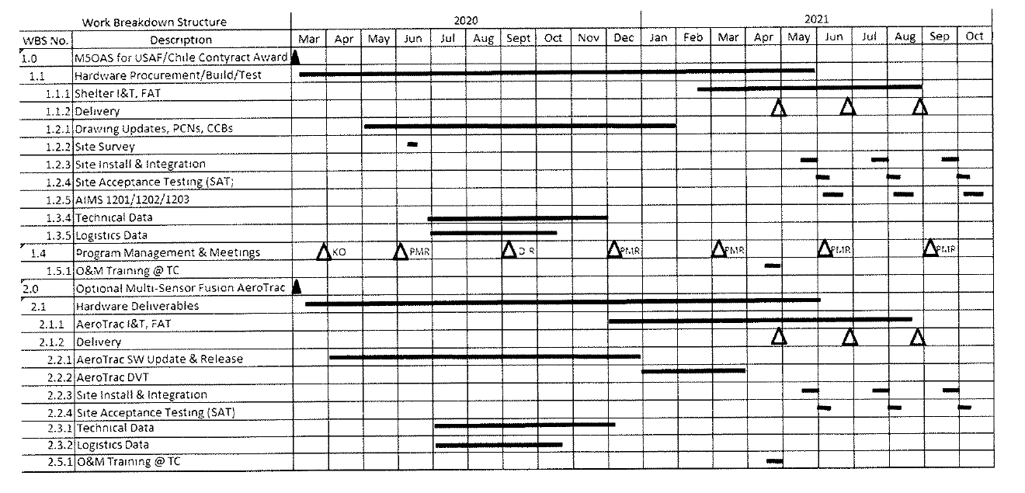

Sample

# C4I Fast-Track Cost Estimate

Provide pricing that is a rough order of magnitude to implement and support the recommended solution. The ROM should include a breakout of the costs for Hardware Software, Program Management, Integration and Installation, Training, shipping and transportation, 3 years of warranty, and 3 years of CLS and help desk.

|  |  |
| --- | --- |
| **C4I Fast-Track Capabilities Pricing Elements** | **Cost** |
| Hardware | $ |
| Software | $ |
| Program Management | $ |
| Integration, Installation and Testing | $ |
| Training (Operator and Maintainer) | $ |
| Logistics (Spares, 3 yrs CLS and 24/7 Help Desk)  Sample | $ |
| Warranty (3 years) | $ |
| Transportation Cost | $ |
|  |  |
| **Total Cost (Excluding USG Program Office)** | $ |

# Exportability

Status of Exportability to Saudi Arabia

# Assumptions

The Industry partner must provide any assumptions that are the basis of the provided pricing and implementation.

* Pricing is for budget estimating purposes and not intended to be a firm fixed price cost
* Country will clear freight through customs within seven days of arrival or after a mutually agreed-upon time
* Country perform site preparation (concrete pad, prime power, etc.)

Sample

* Country responsible for shipping all failed parts during warranty period
* Warranty is a standard return and repair warranty and starts at System Acceptance of each system
* Publications and training will be provided in English
* Excludes transportation and lodging costs for students to attend training courses in U.S. or any other country
* The existing radars will supply ASTERIX data (CAT 001, 002, 008 or 008, 034 and 048)
* Excludes any Value Added Taxes or any other taxes or fees imposed by country

###### **- Glossary**

| **Acronym** | **Definition** |
| --- | --- |
|  |  |
|  |  |
|  |  |
|  |  |
|  |  |
|  |  |
|  |  |
|  |  |
|  |  |
|  |  |
|  |  |
|  |  |
|  |  |
|  |  |
|  |  |
|  |  |
|  |  |
|  |  |
|  |  |
|  |  |
|  |  |
|  |  |
|  |  |
|  |  |
|  |  |
|  |  |
|  |  |
|  |  |
|  |  |
|  |  |
|  |  |
|  |  |
|  |  |
|  |  |
|  |  |
|  |  |
|  |  |
|  |  |